Genetic Algorithm Results:

### Population (Pn) = 100

### Cross Over Factor (Pc) = 0.8

### Mutation Factor (Pm) = 0.2

### Iteration (Nmax) = 100

### α = 0.97

#### **Football Set :: 115 Nodes 441 Edges**

**Output communities:- 7**

**Q value = 0.5695**

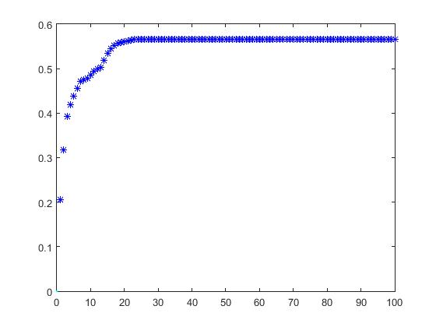

#### **Karate Club :: 34 Nodes 78 Edges**

**Output communities:- 4**

**Q value = 0.4092**

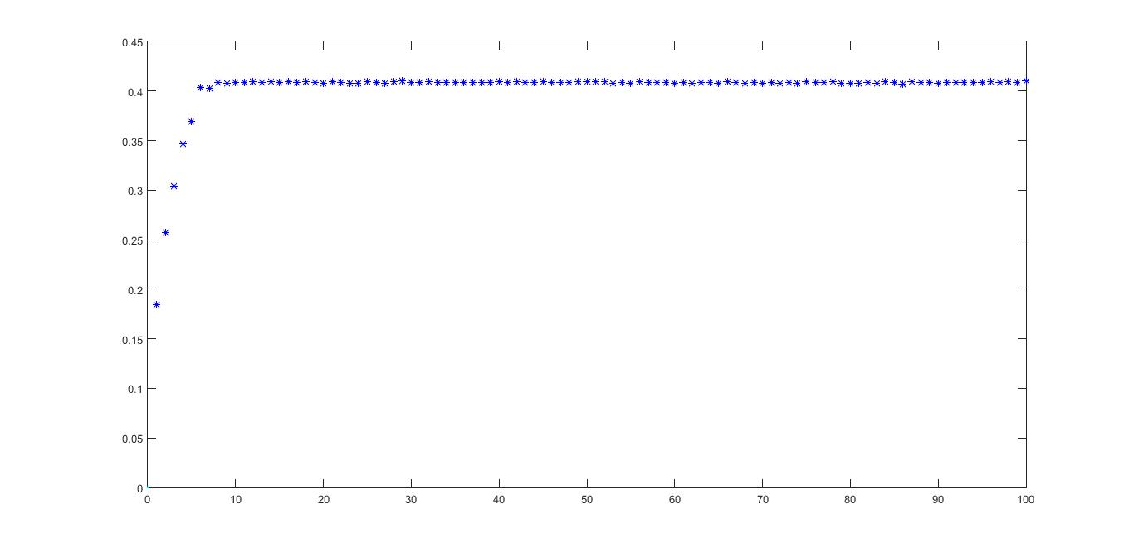

#### **Dolphin Set :: 62 Nodes 159 Edges**

**Output communities:- 4**

**Q value = 0.5342**

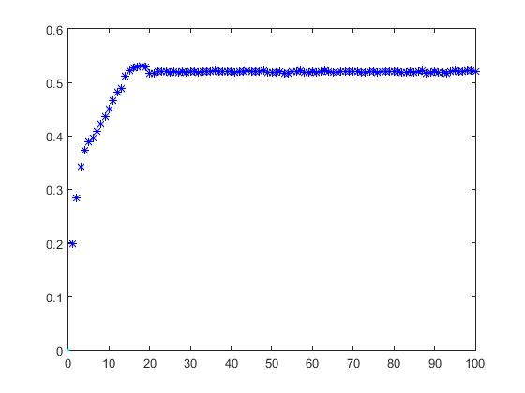

#### **Strike Set :: 24 Nodes 38 Edges**

**Output communities:- 4**

**Q value = 0.6112**

